**Kol Simcha Torah Gazette**

**For parsha vayeilech &**

**Yom Kippur 5786**

Vol 10 Issue 2 (Whole #466) 5 Tishrei 5785/ Sept 27.

& 10 Tishrei/October 4, 2025

**Printed L’illuy nishmas Nechama bas R’ Noach, a”h**

For a free subscription, please forward your request to [***keren18@juno.com***](mailto:keren18@juno.com)

***Past emails can be found on the website ShabbosStories.com under Brooklyn Torah Gazette***

**How to Celebrate**

**Yom Kippur**

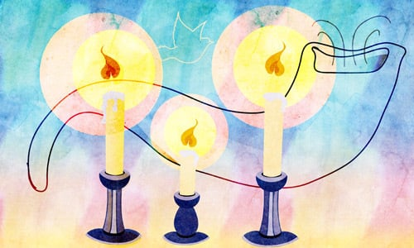

**Art by**[***Sefira Lightstone***](https://www.chabad.org/3159160)

**Yom Kippur In Brief**

What: [***Yom Kippur***](https://www.chabad.org/library/article_cdo/aid/4687/jewish/Yom-Kippur-2025.htm) [***fast day***](https://www.chabad.org/library/article_cdo/aid/4489890/jewish/Yom-Kippur-Fasting.htm) is the holiest day of the year, when we are closest to G‑d and to the essence of our souls. Yom Kippur means “Day of Atonement,” as the verse states, “For on this day He will forgive you, to purify you, that you be cleansed from all your sins before [***G‑d***](https://www.chabad.org/library/article_cdo/aid/433240/jewish/God.htm).”***[1](javascript:doFootnote('1a995354');)***

When: The 10th day of Tishrei (in 2025, from several minutes before sunset on Wednesday, Oct. 1, until after nightfall on Thursday, Oct. 2), coming on the heels of Rosh Hashanah (the Jewish New Year, which is on the first and second days of ***[Tishrei](https://www.chabad.org/library/article_cdo/aid/2263462/jewish/Tishrei.htm" \o "The Hebrew Month of Tishrei)***).

How: For nearly 26 hours we “afflict our souls” by avoiding the following five actions:

Eating or drinking (in case of need, [***see here***](https://www.chabad.org/library/article_cdo/aid/528963/jewish/What-is-the-procedure-for-one-who-must-eat-on-Yom-Kippur.htm) and consult a medical professional and a rabbi)

Wearing leather shoes

Applying lotions or creams

Washing or bathing

Engaging in conjugal relations

Like Shabbat, no work is to be done, and special holiday [***candles are lit***](https://www.chabad.org/library/article_cdo/aid/989590/jewish/Yom-Kippur-Candle-Lighting.htm) before the onset of the holy day.

[**What Is Yom Kippur?**](https://www.chabad.org/4889736)

The day is spent in the synagogue, where we hold five prayer services:

Maariv, with its solemn [***Kol Nidrei service***](https://www.chabad.org/library/article_cdo/aid/5345/jewish/Kol-Nidre.htm), on the eve of Yom Kippur;

Shacharit, the morning prayer, which includes a reading from Leviticus followed by the [***Yizkor memorial service***](https://www.chabad.org/library/article_cdo/aid/371509/jewish/Yizkor-The-Memorial-Prayer.htm);

Musaf, which includes a detailed account of the [***Yom Kippur Temple***](https://www.chabad.org/search/keyword_cdo/kid/15098) service;

Minchah, which includes the reading of the [***Book of Jonah***](https://www.chabad.org/library/bible_cdo/aid/16183/jewish/Chapter-1.htm);

Neilah, the “closing of the gates” service at sunset, followed by the [***shofar***](https://www.chabad.org/library/article_cdo/aid/3061833/jewish/Why-Blow-Shofar-Following-Neilah-After-Yom-Kippur.htm) [***blast***](https://www.chabad.org/library/article_cdo/aid/3061833/jewish/Why-Blow-Shofar-Following-Neilah-After-Yom-Kippur.htm) marking the end of the fast.

Beyond specific actions, Yom Kippur is dedicated to introspection, prayer and asking G‑d for forgiveness. Even during the breaks between services, it is appropriate to recite Psalms at every available moment.

If you would like to purchase a Machzor, the High Holidays prayerbook, click [***here***](https://www.chabad.org/article.asp?AID=1965254).

**What to Do Before Yom Kippur**

Forty days before Yom Kippur, on the first of Elul, we begin blowing the [***shofar***](https://www.chabad.org/library/article_cdo/aid/4837/jewish/Shofar.htm) every morning and reciting Psalm 27 after the morning and afternoon prayers. In Sepharadic communities, it is customary to begin saying [***Selichot***](https://www.chabad.org/holidays/JewishNewYear/template_cdo/aid/4350/jewish/What-Are-Selichot.htm) early every morning (Ashkenazim begin just a few days before [***Rosh Hashanah***](https://www.chabad.org/library/article_cdo/aid/4644/jewish/Rosh-Hashanah-2025.htm))—building an atmosphere of reverence, repentance and awe leading up to Yom Kippur.

For the week before Yom Kippur (known as the [***10 Days of Repentance***](https://www.chabad.org/library/article_cdo/aid/4826/jewish/10-Days-of-Repentance.htm)), special additions are made to prayers, and people are particularly careful with their mitzvah observance.

We are all human, and we occasionally slip. Is there anyone you may have offended or otherwise hurt? Go ahead and ask for their forgiveness. Are you carrying any grudges? Now is the time to sincerely and wholeheartedly let them go.

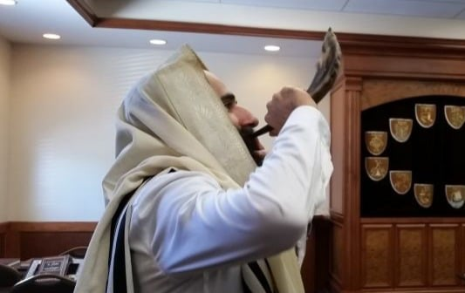

**Blowing the shofar is central to the High Holiday experience.**

**Photo: Chaya Mishulovin, Lubavitch Chabad of Skokie**

Just as Yom Kippur is a day of fasting, the day before Yom Kippur is set aside for eating and preparing for this holy day. Here are some of the activities that we do on the day before Yom Kippur:

[***Kaparot***](https://www.chabad.org/library/article_cdo/aid/989585/jewish/Kaparot.htm) is often performed in the wee hours of this morning

There is a beautiful custom to request and receive a piece of honey cake, so that if, G‑d forbid, it was decreed that we need be recipients, it be fulfilled by requesting honey cake and being blessed with a sweet year

We eat two festive meals, one in early afternoon and another right before the commencement of the fast.

Many have the custom to immerse in a mikvah on this day.

Additional charity is given. In fact, special charity trays are set up at the synagogue before the afternoon service, which contains the Yom Kippur Al Cheit prayer.

Just before the fast begins (after the second meal has been concluded), it is customary to bless the children with the Priestly Blessing.

**What We Do After Yom Kippur**

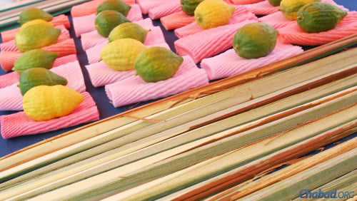

**Lulavim and etrogim for sale in Israel prior to Sukkot (file photo).**

After night has fallen, the closing [***Neilah***](https://www.chabad.org/library/article_cdo/aid/997118/jewish/How-Many-Sets-of-Prayers-On-Yom-Kippur.htm) service ends with the resounding cries of the Shema prayer: “Hear O Israel: G‑d is our L‑rd, G‑d is one.” Then the congregants erupt in joyous song and dance (a [***Chabad***](https://www.chabad.org/library/article_cdo/aid/244369/jewish/About-Chabad-Lubavitch.htm) custom is to sing the lively “Napoleon’s March”), after which a single blast is blown on the shofar, followed by the proclamation, “Next year in Jerusalem.”

We then partake of a festive after-fast meal, making the evening after Yom Kippur a yom tov (festival) in its own right.

Indeed, although Yom Kippur is the most solemn day of the year, it is suffused with an undercurrent of joy; it is the joy of being immersed in the spirituality of the day and expresses confidence that G‑d will accept our repentance, forgive our sins, and seal our verdict for a year of life, health and happiness.

There is a custom that after Yom Kippur, we immediately begin (planning) construction of the [***sukkah***](https://www.chabad.org/library/article_cdo/aid/609535/jewish/What-Is-a-Sukkah.htm), which we will use for the joyous holiday of [***Sukkot***](https://www.chabad.org/library/article_cdo/aid/4784/jewish/What-Is-Sukkot.htm), which follows in just five days.

**Footnotes**

***[1.](https://www.chabad.org/library/article_cdo/aid/995354/jewish/How-to-Celebrate-Yom-Kippur.htm" \l "footnoteRef1a995354)*** [***Leviticus 16:30***](https://www.chabad.org/library/bible_cdo/aid/9917/jewish/Chapter-16.htm#v30).

***Reprinted from the current website of Chabad.Org***

**Rav Avigdor Miller on**

**Yom Kippur Teshuva**

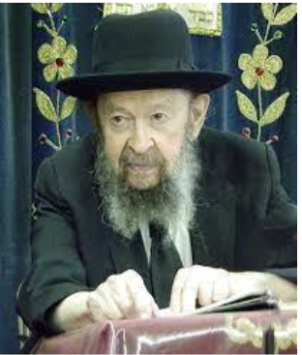

**QUESTION:** On Yom Kippur are we doing teshuva me’ahavah or teshuva me’yirah?

**ANSWER:** It means are we repenting because of love of Hashem, or repenting because of fear of Hashem? Now my friends, let’s be honest and frank and candid and tell the truth. If a man is running out of a house that’s on fire, are we going to ask questions why he’s running? Get out! We don’t care how you do teshuva. Do it any which way. We are not bodek your tzitzis if you’re running out of the house to save your life.

Teshuva me’ahavah is something that requires a very great preparation. To love Hashem is to most of us a very artificial and unreal concept. Now, to be afraid of Hashem, to a certain extent is also unreal but since it’s more attainable, it’s within our reach, so the first thing is we want to live after Yom Kippur.

“Ribono Shel Olam, have pity on us! We see what happened to other people. All around us we have examples, chas vesholom, of great misfortune to individuals. That’s number one. Spare us! שמע קולנו… חוס ורחם עלינו וקבל ברחמים וברצון את תפילתנו.  
Cry out from whatever motivation you can. If you can think of as many examples of tragedies, chas vesholom, that you saw all around you and that’s the motivation, so utilize it! Don’t despise that. Anything that will make your feet run faster out of the fire should be mustered. Any kind of energy that will make you cry out to Hashem and ask for forgiveness, utilize it.

After Yom Kippur, sit down now and start thinking of ways and means of loving Hashem. That’s a career. And we speak a great deal about that here.

Now, a lot of people, especially bnei Torah, don’t think in these terms and they look down on people talking about loving Hashem because of what He is doing for you. Their minds are not accustomed to these thoughts. But they are missing out on one of the greatest forms of success in this life.

Learn to love Hashem that you don’t have a colostomy, a hole in your side. You have a beautiful aperture where it is supposed to be; it’s greased and it functions perfectly. Love Hashem for a normal rectum.

“Ha,” you say, “isn’t that silly?” You’ll go back to yeshiva and they’ll say, “What are you talking about? Love Hashem because of your rectum?!” they’ll say. All right, be a chochom, be a chochom.

But a man who has a colostomy he thinks otherwise. “Oh Hashem,” he says, “if you would just restore me to what I was before. How happy I would be! How I envy those people with a normal life.”

And here is a man, you pass by in the street, he is sentenced to riding around on wheels. He can never walk anymore. Love Hashem that you can walk. And learn to say every morning with great happiness, ברוך אתה ה’ אלוקינו מלך העולם המכין מצעדי גבר – You established the footsteps of a man. It’s such a trick to be able to walk upright, to balance yourself on your two legs.

Isn’t that a wonderful achievement as your thighs swing effortlessly back and forth, you feel no pain in your thighs and your knees flex and relax as your ankles bend and straighten out. And all the bones in your feet are working; there’s lubrication between the joints.

Of course, even if you have, chas ve’sholom, arthritis, you should be happy too that you can walk. But if you don’t have any pains when you walk; it’s a joy to walk. A complicated mechanism; all kinds of pulleys and levers – there are muscles working one way and another. Miracle upon miracle that they are all functioning perfectly. You can walk! That’s a great happiness.

So if somebody will say, “Thank Hashem because I can walk? Ha ha,” he is a letz; he ridicules the great gifts of Hashem.

You have to learn that. That’s how you do teshuva me’ahava. You can’t do teshuva me’ahava just by saying “I’ll decide to do teshuva me’ahava.” You have to spend a lifetime of studying how fortunate you are.

All the blessings that we received in company of the rest of mankind are also blessings. And when a person learns to be grateful to Hakodosh Boruch Hu when rain comes, he’s grateful of the fact that the sun rises every morning. ברוך אתה ה’ יוצר המאורות. How many frum Jews go through that brocha and not once think what it’s talking about? And they will ridicule when they see somebody talking about thanking because of the sun, doing teshuva because he loves Hashem for the sunlight, ha ha.

But every morning you say it, it’s the longest brocha in the siddur. So, it means that you are living like a robot; you don’t know what you’re saying. That brocha means gratitude; that’s teshuva me’ahava.

And therefore when it comes to Yom Kippur, the time is too short. Let’s say when a man is drowning now, let’s say he’s a sick man. Let’s say he has consumption, he has heart disease, he has lots of sicknesses and he’s drowning. So, you are standing on the shore and you have a chart of all his illnesses. So, you say “Well, for his heart disease we have to give him a different diet.” He’s drowning by the way. “For his cancer we have to give him chemotherapy and so on.” No, no, forget about that. Hurl a rope out to him, throw a plank to him, save him first of all. Number one is he needs to be rescued from the waters.

So, on Yom Kippur the first objective is to be saved from the judgment of the Yom Hadin, any which way. If the fear of the grave is effective, use it. Don’t worry that it’s only teshuva me’yira.

And after Yom Kippur settle down now to get more yirah. Yirah is always important! More fear of the grave! Everybody wants to be alive.

But in addition, study the happiness that Hashem gives you every day and all day and little by little you’ll learn to love Hashem.

Maybe next Yom Kippur or maybe twenty Yom Kippurs around you’ll be doing teshvua also me’ahava.

*Reprinted from a recent email of Torah Avigdor based on a lecture delivered on. October 14, 1985 (Tape #568).*

**The Controversy of How**

**Atonement is Achieved**

**on Yom Kippur**

**From the Teachings of the Lubavitcher Rebbe**

**Rabbi Menachem Mendel Schneerson, Zt”l**

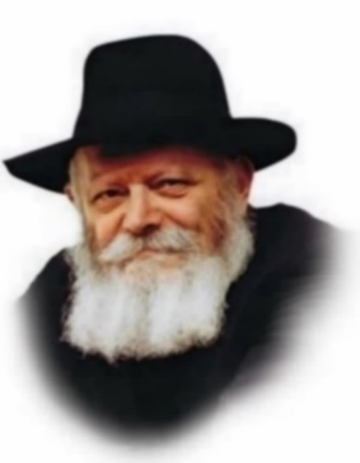

*Reprinted from the Parshas 5762/2001 edition of L’Chaim Adapted from Likutei Sichot of the Lubavitcher Rebbe, Volume 29.*

There is a difference of opinion in the Talmud as to how atonement is achieved on Yom Kippur. Most Sages maintain that Yom Kippur atones for a person's sins only if he does teshuva (repents). Rabbi Yehuda Hanasi, however, contends that repentance is unnecessary, and that the holiness of the day itself effects atonement.

The issue is not whether the sanctity of Yom Kippur atones for sins or not; about that, all are in agreement. According to both opinions, a person who does not repent cannot attain the same level of atonement as one who does. The controversy is only over how the atonement of Yom Kippur is affected.

According to Rabbi Yehuda Hanasi, the G-dly revelation of the "essence of the day" automatically atones for transgressions. The other Sages maintain that in order to reach the higher level of atonement of the "essence of the day," a person must first do teshuva. Having already repented, he can then attain the loftier level that only Yom Kippur can bring about.

Atonement means that a person's misdeeds have been forgiven and he will not be punished. However, the true meaning of atonement is that the person's soul has been purified. When a person sins, his soul becomes defiled. Atonement removes all traces of the sin's impression. When a Jew does teshuva, even his deliberate misdeeds are considered as merits.

A Jew's attachment to G-d exists on many levels. The first level is achieved through mitzvot. When a Jew accepts the yoke of heaven, he forges a connection with G-d.

Then there is the deeper level of connection that expresses itself in repentance. If a Jew transgresses G-d's command, it weakens his relationship with G-d. This disturbs him greatly and prompts him to repent.

The impetus for teshuva emanates from this deep-seated level of attachment. By doing teshuva, all taint of sin is removed, and the bond with G-d is strengthened. Yet even this level is limited in the absolute sense.

The loftiest level is that of the intrinsic connection between the soul and G-d's essence. Completely above all limitations, it transcends even the expression of repentance. A bond of this nature cannot be created through man's actions, nor can it be improved upon. It exists, purely and simply, solely by virtue of the Jewish soul, a "veritable part of G-d above."

Because it is so essential, this highest degree of connection with G-d cannot be weakened by anything, not even by sin. It is untouched by a Jew's repentance or lack thereof. Thus, as regards the supreme level of our relationship with G-d, the "essence of the day" of Yom Kippur achieves atonement.

The lower levels of our connection with G-d require that we actually repent, removing all hindrances to our relationship. But on the highest level that is completely untouched by sin, the atonement of Yom Kippur itself is sufficient.

*Reprinted from the Parshas 5762/2001 edition of L’Chaim Adapted from Volume 4 of Likutei Sichot.*

**Teshuvah on Yom Kippur**

Rabbi Chanina bar Pappa asked Rabbi Shmuel bar Nachman, "What does the following verse mean? And for me, may my prayer be to You, G-d, at a favorable time ([Tehillim 69:14](https://www.sefaria.org/Psalms.69.14?lang=he-en&utm_source=aish.com&utm_medium=sefaria_linker))." He replied, "The gates of prayer are sometimes open and sometimes closed, but the gates of teshuvah are always open."

Rabbi Chanina responded, "How do we know this?"

He replied, "The verse says, With wondrous acts in Your righteousness You answer us, G-d of our salvation, the trust of all corners of the earth and the distant seas (ibid. 65:6). Just as a mikveh is sometimes open and sometimes closed for purification, so too, the gates of prayer are sometimes open and sometimes closed. However, just as the sea is always open for purification, so too, the hand of G-d is always open to accept penitents." ([Devarim Rabbah 2:12](https://www.sefaria.org/Devarim_Rabbah.2.12?lang=he-en&utm_source=aish.com&utm_medium=sefaria_linker))

To understand the gist of this, let us discuss the general idea of taharah (purification). When a vessel, or a person, requires taharah, a mikveh, a specially prepared body of water, is used. It is a basic requirement of this procedure that the entire person or vessel must be totally submerged in the water.

If even the most minute area of the person remains outside the water, the tevilah (immersion) is completely invalid and must be repeated. However, if water itself becomes impure, it need only touch the waters of the mikveh in the slightest way, and it immediately becomes tahor.

A detailed discussion of the laws of tumah and taharah (impurity and purity) and how they apply is beyond the scope of this essay. We are primarily concerned here with the symbolic aspects of different sorts of taharah.

We may compare the purifying effects of water with tefillah (prayer). The purpose of tefillah is to enable the supplicant to cleave to G-d. Every part of one's being is supposed to be involved: all of one's physical senses and certainly the whole of one's spiritual makeup must be concentrated on the act of tefillah. If one fails to muster one's entire physical and spiritual abilities to prayer, then the situation is similar to the person who uses the mikveh but leaves part of his body outside the water - his tefillah is ineffective.

However, if it is a time of special Divine grace, the "favorable time" described above, then the situation is somewhat different. This produces a particular relationship between G-d and Klal Yisrael, one of a more "face-to-face" variety. At this time of favor, a similar sort of favorable nature is awakened in the individual with which he may approach G-d. Since this permeates his entire being, it encompasses all his senses, enabling him to connect directly with G-d.

This helps us understand the above midrash. A mikveh is sometimes useful for purification and sometimes not. It is only effective if a person is able to immerse himself completely in the water. So, too, tefillah is usually only effective if a person can invest his entire being in it. But when water becomes defiled, the smallest contact with the mikveh is sufficient to restore its purity.

Teshuvah literally means return - return to the essential self. When a person performs sincere teshuvah he reestablishes contact with the root of his soul - the pristine holiness that is within him. The slightest connection with this innate holiness removes the defilement of sin from him. Just as the sea is always open and available, so too, the path to this sort of purification is always open to him. During the Ten Days of Repentance and especially on Yom Kippur itself, it is much easier to achieve this sort of relationship with G-d. As our Sages tell us:

Seek out G-d when He is to be found ([Yeshayahu 55:6](https://www.sefaria.org/Isaiah.55.6?lang=he-en&utm_source=aish.com&utm_medium=sefaria_linker)) - these are the ten days between Rosh HaShanah and Yom Kippur. ([Rosh HaShanah 18a](https://www.sefaria.org/Rosh_Hashanah.18a?lang=he-en&utm_source=aish.com&utm_medium=sefaria_linker))

Perhaps the two sorts of taharah that we have mentioned correspond to the two sorts of offerings brought on Yom Kippur, the mussafim and the special once-a-year sacrifices. The mussafim, as their name suggests, are additional to the usual, daily, continual offerings. As such, they represent the special holiness of every Yom Tov, which finds its expression in the Yom Tov Kiddush:

You chose us from all people and raised us above all tongues. (Siddur, Kiddush of Yom Tov Eve)

This corresponds to the extra closeness and special favor G-d feels for His chosen people. As we have said, this awakens a favorable nature in klal Yisrael and gives them the ability to connect completely with G-d, like a person who achieves purity by immersing totally in the waters of the mikveh. This happens on every Yom Tov, and Yom Kippur is no exception.

However, with the special offerings of Yom Kippur, we find a new idea, which occurs nowhere else:

For on this day He will atone for you, to purify you; from all sins before G-d you will purified.([Vayikra 16:30](https://www.sefaria.org/Leviticus.16.30?lang=he-en&utm_source=aish.com&utm_medium=sefaria_linker))

Klal Yisrael come before G-d on Yom Kippur and are purified by a slight touch, for just coming into contact with the day brings atonement. This is like the case of the impure water, which merely requires contact with the mikveh to achieve purity. This, of course, corresponds to the teshuvah aspect of Yom Kippur, a feature shared by no other Yom Tov.

**Cleansing the Whole Person**

As we have seen, the Aseres Yemei Teshuvah (Ten Days of Repentance), which last from Rosh HaShanah to Yom Kippur, are an opportunity to repent of our misdeeds and reestablish our relationship with G-d. If this is so, then we must be given the possibility to change every aspect of our lives and thus our personality. Every person consists of three major parts: the body, the soul, and the intellect. Let us see how the Yamim Nora'im provide us with the chance to revise the direction of each of these primary components.

Rosh Hashana is the "head of the year," as its name suggests. It is not, however, just a name for the festival. Rosh Hashana is literally the "head" of the whole year. Just as the intellect of a person reposes in his head and directs his actions, so too do the occurrences on Rosh Hashana affect the success of the entire year. On Rosh Hashana, the focus of the day is an intellectual acceptance of God's rulership of the entire world. Rosh Hashana, then, is the Jew's chance to revise the direction of his intellect and harness it to the service of G-d.

Once we have established the correct frame of mind on Rosh Hashana, the remaining days until Yom Kippur provide a framework within which to work on the soul, that is, the emotional part of the personality. During this time, we perform the ritual of kapparos, in which we symbolically transfer our misdeeds onto a chicken or money. This is, as it were, a "soul for a soul." We are expected to examine our deeds during this time and arouse within our souls a great longing for repentance and our lost connection to the Divine.

Finally, after all this preparation, we are ready to refine our bodies, our most physical component, through the act of eating. We may not ingest food on Yom Kippur itself, so we eat our meal shortly before the fast commences. This has the status of a mitzvah meal, in which we demonstrate our ability to use the food for holy purposes, in this case, strengthening our bodies for the fast ahead.

It is only now, having worked on every aspect of his being during the preceding days, that the Jew can enter Yom Kippur, a day with special powers. As we saw above, G-d promises:

For on this day, He will atone for you, to purify you; from all sins before G-d you will be purified. (Ibid.)

This verse has three phrases, implying the three sorts of purification we just mentioned. The cleansing process of this holiest of days can only start once one has already sublimated one's physical, intellectual, and emotional powers as much as possible. After we have cleansed ourselves as much as we can, we enter Yom Kippur, on which G-d guarantees that He will complete the task. This opportunity comes but once a year. If we utilize it to the best of our abilities, we are assured of a fine and sin-free start to the new year.

Excerpted from [Shem MiShmuel](http://www.targum.com/product.php/37/shem-mishmuel---by-the-sochatchover-rebbe?a=aishhatorah) by the Sochatchover Rebbe, rendered into English by Rabbi Zvi Belovski, published by [Targum Press](http://www.targum.com/product.php/37/shem-mishmuel---by-the-sochatchover-rebbe?a=aishhatorah).

*Reprinted from the Yom Kippur website of aish.com*